LeetCode Program 1281
Link :- https://leetcode.com/problems/subtract-the-product-and-sum-of-digits-of-an-integer/
Successful Submission
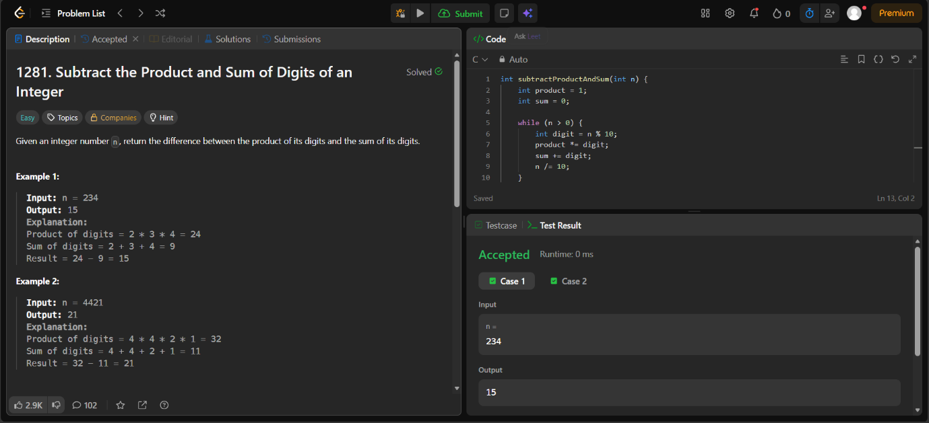
Source Code


